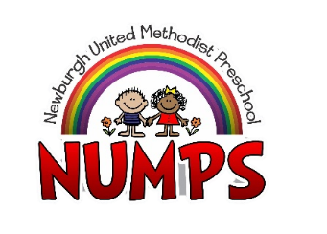
Extended Enrichment/Young 2’s & 3’s Tuition Agreement 2021-2022
This agreement is entered into by the undersigned parent/guardian (referred to as “you” or “your”) of the child/children named below and Newburgh United Methodist Preschool (NUMPS) (referred to as “we”, “us”, “our”, or “school”) on the terms and conditions set out below:
_____ Extended Enrichment – Child will be utilizing Extended Enrichment program at $15 per day.
_____ Young 2’s & 3’s - Child will be attending Young 2’s & 3’s class at $15 per day.

- Your student’s monthly tuition is due by the 5th of each month. There will be no tuition credit and/or refund due to closures, scheduled or otherwise; with the exception of Fall Break, Thanksgiving Break, Christmas Break and Spring Break. (See Calendar at a Glance for dates.)

- Because our program requires us to engage staff based upon the number of children enrolled, we cannot give tuition refunds or vacation credit for days your child is absent.

- If NUMPS has to move to remote learning and you choose to no longer pay tuition, your child will be un-enrolled and no longer have access to the class Facebook page for teacher instruction or accessibility.

- All payments received after the 5th of each month will be charged a $25.00 late payment fee.

- A $25.00 fee will be assessed for all NSF checks or other forms of returned payments.

- All fees may be paid by cash, check, money order, PayPal app or website, or NUMPS website Tuition Tab.

