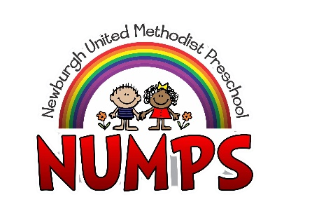
Older 3’s & Pre-K Tuition Agreement 2022-2023
This agreement is entered into by the undersigned parent/guardian (referred to as “you” or “your”) of the child/children named below and Newburgh United Methodist Preschool (NUMPS) (referred to as “we”, “us”, “our”, or “school”) on the terms and conditions set out below:
_____ OLDER 3’s - Tuesday and Thursday: $125/ month
_____ OLDER 3’s - Tuesday, Wednesday and Thursday: $150/month
_____ PRE-K - Monday, Wednesday and Friday: $150/month
_____ PRE-K - Monday - Friday: $200/month

- Your student’s monthly tuition is due by the 5th of each month. There will be no tuition credit and/or refund due to closures, scheduled or otherwise.

- Because our program requires us to engage staff based upon the number of children enrolled, we cannot give tuition refunds or vacation credit for days your child is absent.

- If NUMPS has to move to remote learning and you choose to no longer pay tuition, your child will be un-enrolled and no longer have access to the class Facebook page for teacher instruction or accessibility.

- All payments received after the 5th of each month will be charged a $25.00 late payment fee.

- A $25.00 fee will be assessed for all NSF checks or other forms of returned payments.

- All fees may be paid by cash, check, money order, PayPal app or website, or NUMPS website Tuition Tab.

_____________________________________________________________________________
Child/Children’s Name(s):

_____________________________________________________________________________
Parent/Guardian Signature Date
______________________________________________________________________________Parent/Guardian Signature Date

